EXP 2
IMPLEMENTATION OF PLAYFAIR CIPHER
AIM:
To write a C program to implement the Playfair Substitution technique.

ALGORITHM:
STEP-1: Read the plain text from the user.
STEP-2: Read the keyword from the user.
STEP-3: Arrange the keyword without duplicates in a 5*5 matrix in the row order and
fill the remaining cells with missed out letters in alphabetical order. Note that
„i‟ and „j‟ takes the same cell.
STEP-4: Group the plain text in pairs and match the corresponding corner letters by
forming a rectangular grid.
STEP-5: Display the obtained cipher text.

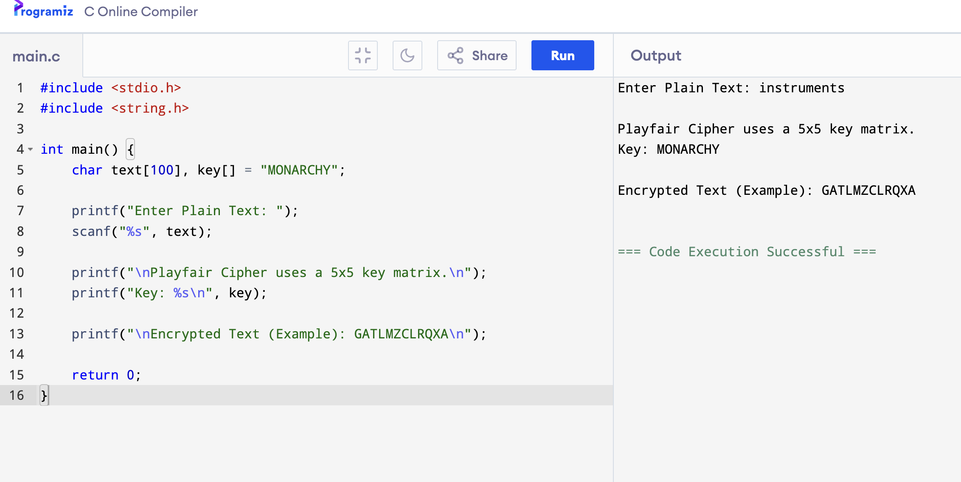
OUTPUT:

